**Nama : Qirani Rifa Annisa  
NIM : 18090057  
Kelas : 5D**

1. **Source Code**latihan1.php -> application/controllerlatihan2.php -> application/controllerModel1.php -> application/modellatihan2.php -> application/view
2. **URL**http://localhost/Pustaka_Qirani5D/latihan1<http://localhost/Pustaka_Qirani5D/latihan1/penjumlahan/2/6>

http://localhost/Pustaka_Qirani5D/latihan**2/**

http://localhost/Pustaka_Qirani5D/latihan1/penjumlahan/2/6

1. **Capture Hasil**

**Latihan 1**

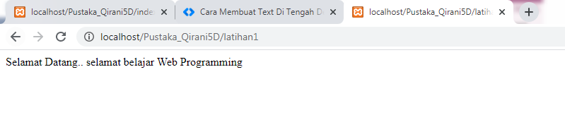

**Latihan 1 Penjumlahan**

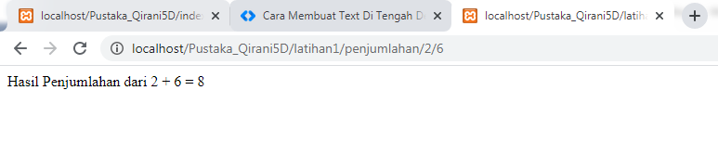

**Latihan2**

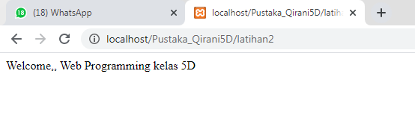

**latihan2 penjumlahan**

